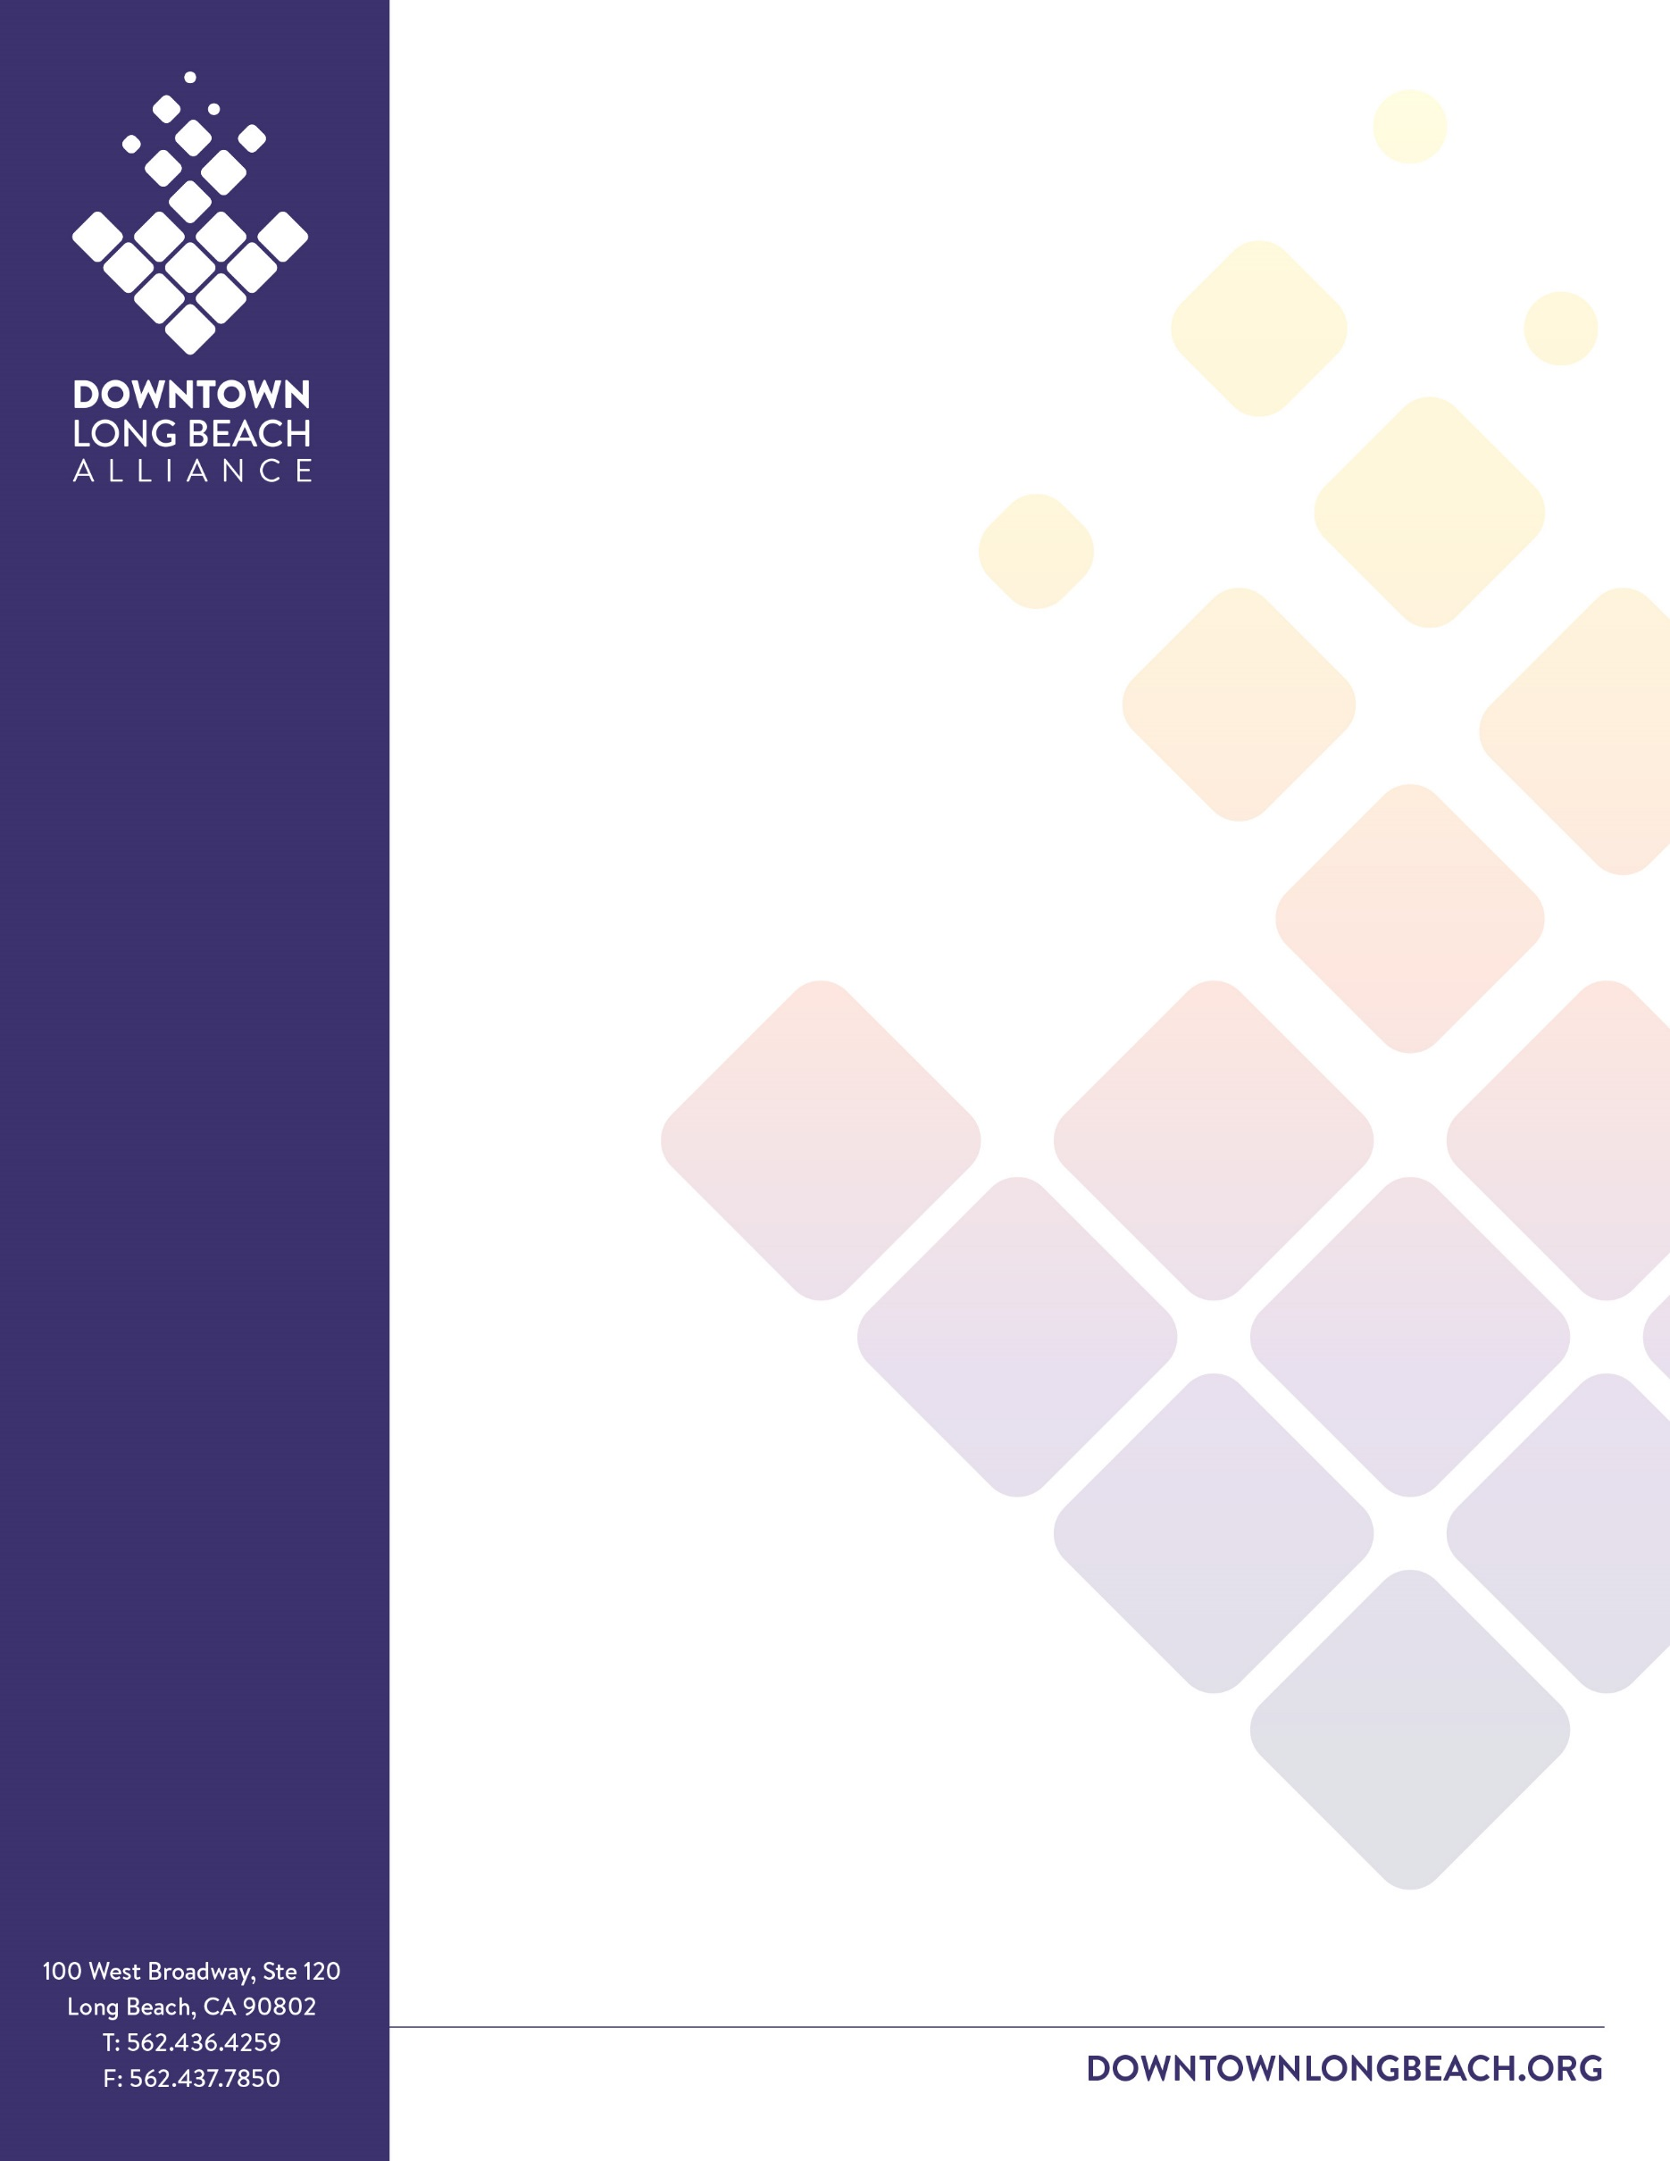
FINANCE COMMITTEE MEETING MINUTES

Friday, July 23, 2021

10:00AM
Join Zoom Meeting
Meeting ID: 812 4640 3426
Passcode: 999071
Voting Present: Debra Fixen, Kena Fuller, Bob Kelton, Hilda Sanchez
Voting Absent: Jill Harris
DLBA Staff: Jeremy Ancalade, Kelsey Mader

- CALL TO ORDER – Debra Fixen, Treasurer
Meeting presentation. Called to order at 10:02 AM.

- ACTION: Approve Minutes from May 28, 2021 Meeting
1st: Hilda; 2nd: Kena
VOTE: None opposed. No abstentions. Motions passes.

- FINANCE REPORT: Jeremy Ancalade, CFO
FINANCE COMMITTEE:
Debra Fixen
Treasurer

Kena Fuller

Jill Harris

Bob Kelton

Hilda Sanchez

STAFF:
Jeremy Ancalade
CFO

Kelsey Mader
Executive Assistant

Kraig Kojian
President & CEO
  - Year-to-Date DRAFT Financial Report through June 30, 2021
- Preforming ahead of budgeted figures. Revenue is below budgeted target and expenses are below. Expenses are driving the surplus.
- PBID is expected to be on budgeted, but DPIA and Parking Meter Revenue are anticipated to fall short.
- Year end should be even, but currently timing variances are causing.
- Sanchez and Ancalade discussed DPIA preforming under budget due to the City waiving business license late fees.
- Fixen and Ancalade reviewed an increase to hourly wages paid to the Clean & Safe Team to help with employee retention. Whenever this goes into effect it will greatly impact the Operations budget.
  - Cash Flow Report

- STAFF REPORT: Kraig Kojian, President and CEO and Jeremy Ancalade, CFO
- Ancalade reviewed the initial draft of the 21-22 budget, breaking down key shifts within each department.
- Fixen discussed events hosted and sponsored by DLBA, emphasizing the importance of supporting events that benefit all part of Downtown, not just the Downtown core.

- OLD BUSINESS

- NEW BUSINESS

- PUBLIC COMMENTS

- ADJOURNMENT
Meeting adjourned at 10:25 AM.
NEXT FINANCE COMMITTEE MEETING:
Friday, September 24, 2021
10:00 am.
Location: Zoom
DLBA Mission: Cultivate, preserve, and promote a healthy, safe, and prosperous Downtown
All meetings held by the Downtown Long Beach Alliance shall be conducted in compliance with the Brown Act, California Government Code Section 54950 et seq., and its requirement that public commissions, boards, councils, and public agencies conduct business openly. The agenda and supporting documents are available on the Internet at http://downtownlongbeach.org. E-Mail correspondence regarding agenda items can be directed to info@dlba.org. Agenda items may also be reviewed as posted in public view at the DLBA offices or at City Hall. If special accommodation is desired pursuant to the Americans with Disabilities Act, please make your request by phone to (562) 436-4259, by noon the day prior to the meeting.

